**4CS401: Cryptography and Network Security**

**B.Tech. (CSE) – I [ 2022-23 ]**

**Assignment No - 9**

**Euclidean and Extended Euclidean**

**Title: Euclidean and Extended Euclidean**

**Aim: To Demonstrate Euclidean and Extended Euclidean**

**Theory:**

**Euclidean algorithm is used to find a GCD of 2 numbers. Extended Euclidean helps to find the inverse of the number.**

**Code :**

**#include <bits/stdc++.h>**

**using namespace std;**

**// Function for extended Euclidean Algorithm**

**long long gcdExtended(long long a, long long b, long long *x, long long *y)**

**{**

**cout<<a<<" "<<b<<" "<<" " <<*x <<" "<<*y<<"\n";**

**// Base Case**

**if (b == 0)**

**{**

**return a;**

**}**

**long long q = a / b;**

**long long x1 = *y;**

**long long y1 = *x - q * (*y);**

**long long gcd = gcdExtended(b, a % b, &x1, &y1);**

**return gcd;**

**}**

**// Driver Code**

**int main()**

**{**

**long long x = 0, y = 1, a, b;**

**cout << "\n Enter a and  b to find GCD";**

**cout << "\n a = ";**

**cin >> a;**

**cout << "\n b = ";**

**cin >> b;**

**long long g = gcdExtended(a, b, &x, &y);**

**cout<<"GCD("<<a<<", "<<b<<") = "<<g<<endl;**

**return 0;**

**}**

**Output 1:**

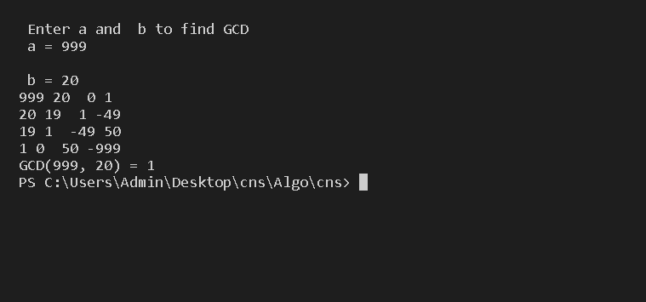

**Output 2:**

